Annual Report
March 2016 to April 2017
Work for Equality is a non-government organization, started with the vision to build capacities of the marginalized communities on various areas, so that they can mingle with mainstream of the society and live their life with dignity. This year we reached up to the 5366 Number of deprived communities and their various stakeholders like children, women, youth etc.
To reach up to the vision, we have selected area of education and started work on it through initiative called “PRERANA”
“PRERANA” is a platform for the holistic development of deprived community children. Through PRERANA we are supporting the children do not get positive environment at home and community for their educational development. Our beneficiaries are mainly the children having risk of school dropout due to bad socio- economic condition, maximum children are living on footpath and not getting supportive environment for schooling. The way they are living not only their physical but also their psychological health is in risk. Currently 330 children and approximately 660 parents and seven communities are taking benefits of the program.
Through PRERANA initiative we are providing following services such as
- Study guidance
- Educational kits
- Life Skills Sessions
- Counseling
- Yoga and sports
- Nutritious food
- Parents meetings
- Home visits
- Medical support etc.…
Behavior Change through PRERANA initiatives:
At the beginning we found parents were least interested for their children’s education but after the certain time they shared “our children should be educated though we didn’t get education opportunity” this is the major change we can able to bring in parents throughout the small period. Many parents showing their interest to get admission their child in PRERANA center.
Maya & Naina are staying on footpath with their parents in Pune, Maya dropout from school due to parent’s migration, we helped Maya’s parents to reenrolled Maya in Z.P. school and Naina get admission in PRERANA center
”Akash, belongs to Koregaon village PRERANA center, he is studying in 6th standard. At the beginning, due to his poor economic and social condition he felt uncomfortable to participate with other community children, our PRERANA teachers Priya and Kalhani provided him required counseling and support, now he has slowly started mingle with other children, his confidence is increasing”
“Hiraman other student belongs to Varale village PRERANA center was misbehaving with other children. He belongs to very orthodox family where they are following patriarchy. He fights with other children and even didn’t take interest in study, Our PRERANA teacher gave him special attention provided him counseling, now his regular school teacher is saying “he is changing a lot, thanks to PRERANA center”
“Kapil belongs to Eainade PRERANA center, studying in 4th standard had behavior problem, he didn’t talk to anybody, when he got admission in PRERANA, PRERANA teacher observed he even couldn’t read and write. If teacher asked him something he started throw stones on them, it was all about his family problem and violent environment, PRERANA teacher provided him required support and now he is one of the best student who is regular member of PRERANA center. He is slowly improving in studies”
“Akshaya belongs to Talegaon center studying in 3rd standard, her mother was beating her lot on simple issues, our PRERANA teacher provided Akshaya’s mother required support, gave her friendship, understood her frustration now Akshaya mother’s changing her behavior a lot, whenever our PRERANA teacher goes for home visit she happily shared developing relationship with Akshaya .
“PRERANA teacher from Varale center shared “Sunita Thakar one of the parent belongs to Varale center said, PRERANA is a great initiative for our tribe children, our children leave school because of they are having fear from general community, and through this initiative our children are overcoming on fear and try to mingle with other community children”
Janvi Thakar One of the student shared “I never know, in summer holidays we can have such fun in school, this is first time where I learnt so many different things in holidays and I would like to participate in summer camp again and again” another participant Pranjal and Sanskruti shared “we wish this summer camp should never finished”, Sarthak studying in 3 standard was basically shy nature, he wanted to participate but his nature does not allow him to participate in fun activity, due to summer camp his behavior changed a lot and he slowly overcome on his shy nature. PRERANA teacher from Eainade shared, not only regular children but the children studying in ASHRAM school also participated in summer camp, they enjoyed a lot, next year also they would like to participate in summer camp again. Children not only enjoyed in summer camp but also they learnt livelihood skills out of that, “Vinod studying in 6th standard and Anil studying in 8th standard, made Scooby bracelet and their mother sold it in market, they got good profit out of that, they will use this money for their educational purpose” shared PRERANA teacher from Talegaon PRERANA center.
During goal orientation session in summer camp, many children Shared, “they want to become teacher just like our PRERANA Tai because we like the way they teaches us”. This was the happiest movement in our life shared by PRERANA teacher, PRERANA teacher from Varale shared ” now parents are happy because their children start helping them in domestic work and this impact happened because of our behavior change session ”
Sport is one of the importance part in children’s life. We conducted sports sessions on Saturday and Sunday along with nutrition. It was observed during playing even small boys and girls are not willing to play together, hold hand because they are taught that boys and girls should not play together, due to our sport initiatives now both boys and girls are playing together and parents also taking it naturally.
Through reading sessions during PRERANA class.it is helping a lot to improve children’s reading skills. “Payal and Sanjay are studying in third standard, both of them were weak in reading skills. Their Parents and teacher were worried about their performance. But after given special attention through PRERANA reading sessions, they are improving a lot in reading
Sport is making tremendous change in children’s life. Mokina Dond styding in 2nd standard, was not like to participate in any activities conducted by PRERANA teacher except sport, due to regular participation in sport activity now she slowly showing her willingness to participate other activities, not only that she also start to listen others.

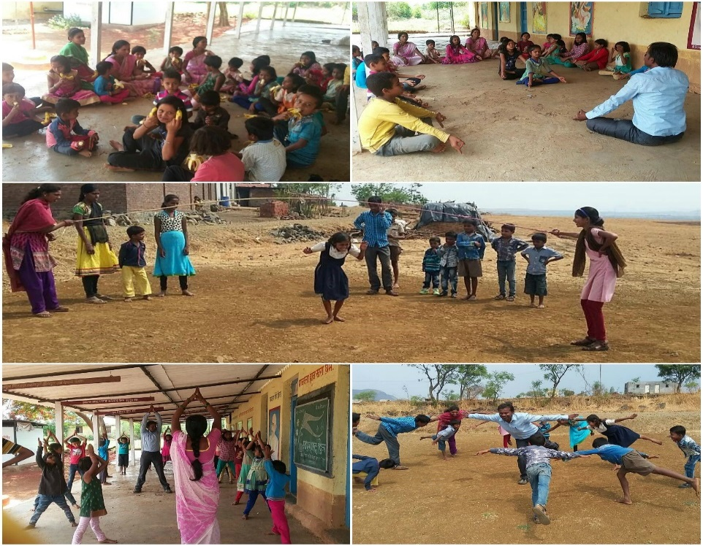

Necessary Supports to other schools.
No | Name of the beneficiary schools | Provided support | Number of beneficiaries
1 | Talegaon Dabhade – Anganwadi school no 13 and Boudh Wasti Anganwadi | Toys for the children | 70
2 | School no 13 Talegaon Dabhade | Shoes for the children | 349
3 | Dehuphata Sant Tukaram Nagar school and community children | Educational kits | 250
4 | Koregaon, Eainade, Koregaon Anganwadi, Londhewasti Anganwadi, Rajubai school and Anganwadi | Shoes | 205
5 | Koregaon, Rajubai and Eainade village | educational kit | 150
6 | Talegaon School, Anganwadi, Boudh wasti Anganwadi, Koregaon Z.P school, Anganwadi, Londhewasti Anganwadi, Rajubai Z.P School and Anganwadi & Eainade Z.P. school and Anganwadi | Nurtured potential through various activities like drawing, songs, Rangoli etc. | 624
Total |  |  | 1648

KISHORI and Women GROUPS - one of the major objective of our organization is to empower young girls/women through providing them knowledge and skills. We started library for the girls. The awareness sessions helped them to increase their knowledge. The result of this programs is that, three girls and one boy who stopped their education after 9th, 10th and 12th grade due to poor economic condition, they decided to complete their education with the support of organization. Two of them got admission in Indrayani College Talegaon Dabhade.
Success story: Shilpa one of the participant of youth group has been engaged at the age of 15 years. When she starts regularly participated in the group meeting, she realized that, child marriage is not good and she should stand against it. Not only Shipla but also all Kishori group members realized that they should support to Shilpa, one of the fine day all Kishori group members visited Shilpa’s parents and convinced them for canceled the marriage. The communication through group was so effective and the impact was her parents realized their fault and ready to cancel marriage. Now Shipa is studying in 11th standard and empowering herself through regular attending group meetings.

No | Day Celebration | Program | Beneficiary
1 | International women’s Day | - Awareness talk on reproductive health  - Fun activities  - Gifts for participants  - Tree plantation | 250
2 | Savitribai Phule Jayanti | - Start books library for children  - Fun activities  - Gifts for participants | 50
3 | Celebration of World Day against Child Labour | - Participation in Marathon  - Educational kits for the children  - Workshop for children on child rights  - Participation in “happy street” program  - Fun activities | 270
4 | Celebration of International Human Rights Day | - Human Rights Workshop for youth and rally  - Distribution of Human rights books to the youth | 300
5 | Celebration of HIV/AIDS Day | - Awareness workshop for adolescent girls on HIV/AIDS  - Awareness workshop of parents on HIV/AIDS and responsible parenting | 70
6 | Children’s Day | 3 programs (school and two community ) | 120
Total |  |  | 1060
.
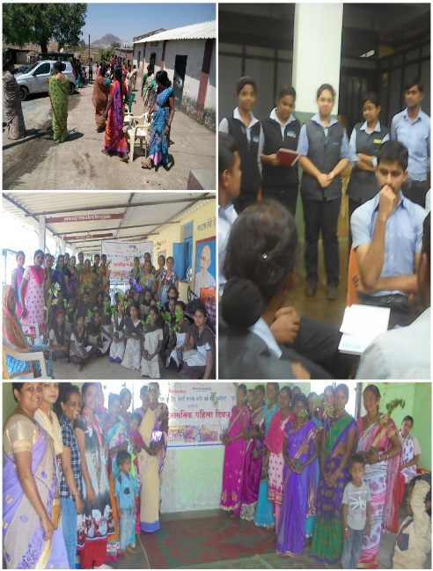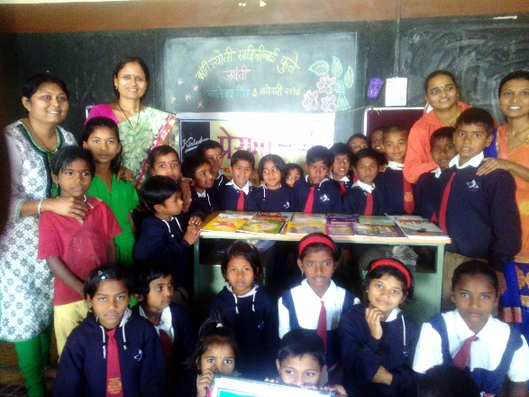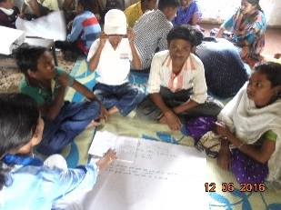

Community Development:
No | Program | Beneficiaries
1 | Livelihood program – advanced tailoring course | 30 women
2 | Support community for to solve water issue | 500 villagers
3 | Constructed school compound wall | 125 students
4 | Formation of community women group / Mandal called Ranragini | 40 women
5 | Eye checkup camp | 150 children and villagers
6 | Specs distribution | 72
7 | Medical camp | 3
8 | Sponsorship support for higher education | 1
Total |  | 771

Success stories: after successfully completion of the advanced tailoring course, approximately 15 women start their own small tailoring business at home. This course helped women to increase not only economic status but also social status.
Access to water: we found one of the tribe community is struggling to get water form many years. Due to lack of water availability young girls are not able to come to school and entire day they need to spend for collect water. We found there is a need of solidarity in the community to fight against water issue. To mobilize the community we are conducting meeting with villagers and understand them importance of harmony. These meeting are motivating tribes to come together and taking responsibility to solve problem.
Women Empowerment: Eainade Thakar community are facing water problem, the women need to cross two mountain to collect water, Work for Equality trying to bring the community together and try to solve the problem. The first step is we form “Women Group” “Ranragini” the group has started meeting frequently to solve their problems.
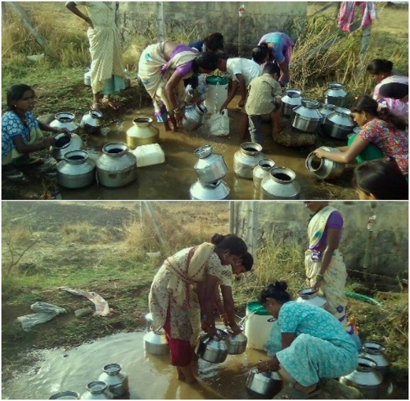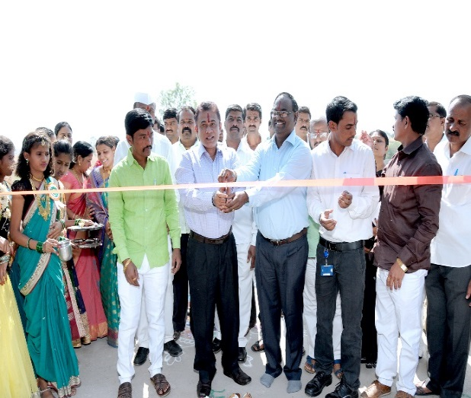

Capacity building of staff:
No | Program | Number of trainings | Topics | Beneficiaries
1 | Monthly planning meeting | 12 |  | 60
2 | Monthly capacity building training | 12 | Gender, reproductive health, documentation, case studies, parent’s participation, health and hygiene etc… | 50
3 | Participation in other training programs | 7 | urban and rural development, inclusion, sexual abuse, reproductive health, reading writing skills, child, training resources, NGO strategy management | 6
4 | Summer camp training | 4 | Child sexual abuse, gender, reproductive health, nutrition etc.. | 11
Total |  |  |  | 117

Capacity building training
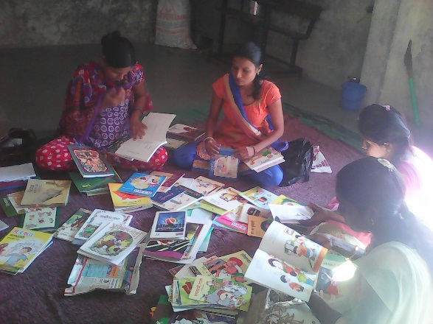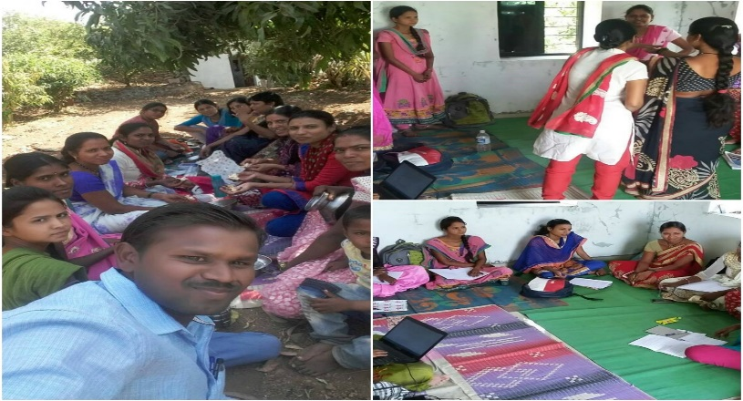
Training program on health organized by SNEHA and two staff were participated in two days residential training program organized by ALOCHANA NGO on “INCLUSION”, where they got experience to meet with representative of minorities and understand their concerns. Participated in National Urban Health mission training program.
Technical support
No | Name of the companies | number of programs/ workshops | Topics | Beneficiaries
1 | Pune university | 2 | Life-long needs of rural youth and women | 100
2 | Gabriel, continental and Mahindra Spare parts, Magna international India etc.. companies | 19 | Sexual harassment of women at workplace | 950
3 | Jankidevi Bajaj | 1 | HIV/AIDS and responsible parenting | 60
Total |  |  |  | 1110

Achievement of this year
- Sar Senapati Award
- Article published in Chuliplhad magazine

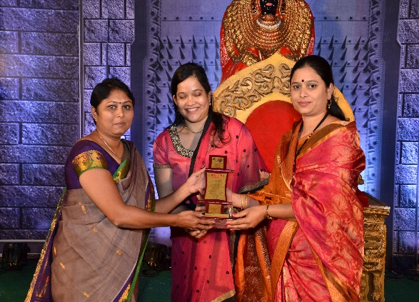
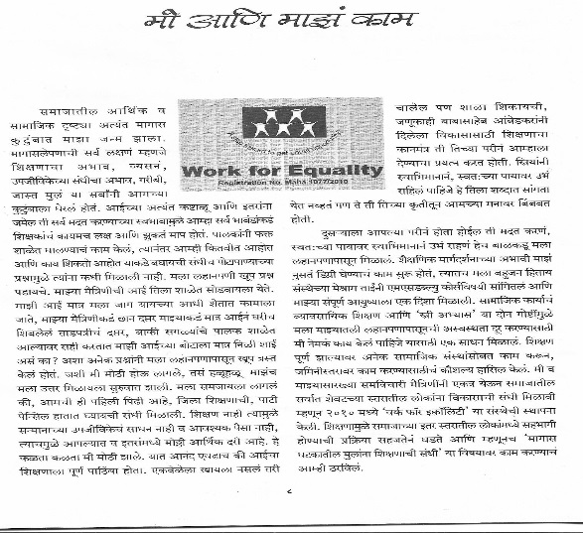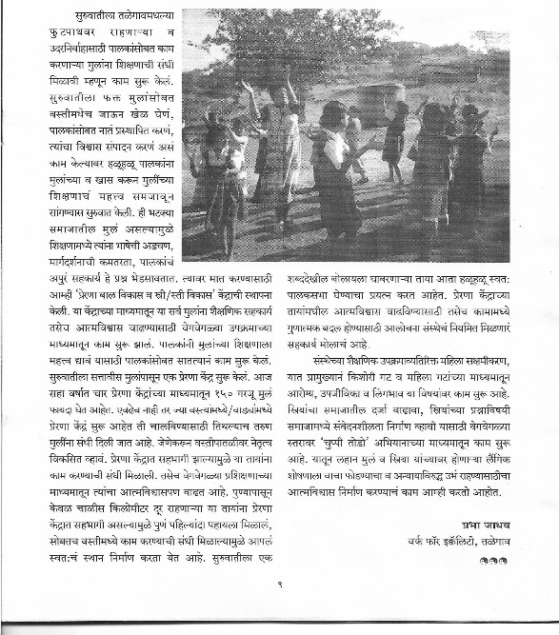

Work for Equality has felicitated by Maval Pratishan and Umabai Dabhade Pratishthan with “SARSENAPATI” award for our social contribution by wife of MLA Mr. Bala Bhegade.

Supporters
Cycle ride by Earn blessings group: had done cycle ride for to raise fund for the marginalized community children’s Education. Through this support we will be able to support 80 needy children throughout the year
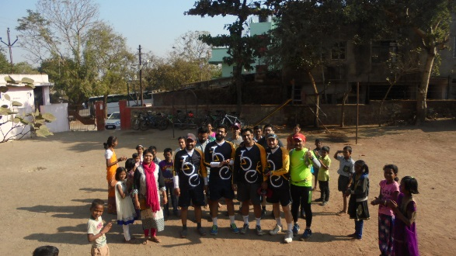

Big Thanks to Our supporters and Well-wishers
• Alochana
• Training for Development Scholarship Society
• Schindler India Pvt. Ltd
• Kirloskar Oil Engines
• Earn blessings
• Tech Mahindra
• Gabriel Pvt. Ltd
• L’OREAL
• Mahindra Spare Parts
• Continental India
• Air Liquide foundation
• Goonj
• Knowledge White board
• Kshitij
• Rotary Club of Talegaon MIDC
• LIONS Club Talegaon
• Education Department Talegaon
• Lokmanya Tilak School No 3 Talegaon
• Koregaon village Z.P. School
• Rajubai Vasti Z.P. School
• Varale Village Z.P. School
• Sant. Tukaram Nagar Z.P. School – Yelwadi
• Eainade Vasti Z.P. School
• Rotary Club of Pune Royal
• Rotary Club of Panvel
• Savitribai Phule Pune University
• Youth for Human Rights
• PANAN Sanchanalay Maharashtra Shashan

